Odd Semester (2021)



**BINUS UNIVERSITY**

**BINUS INTERNATIONAL**

|  |
| --- |
| Assignment Cover Letter  (Individual Work) |

**Student Information:**

**Surname:Hasan**   **Given Name:Andrean**   **Student ID Number: 2501982550**

**Course Code :** COMP6047001 **Course Name :** Algorithm and Programming

**Class :** L1AC **Lecturer :** Jude Joseph Lamug Martinez, MCS

**Type of Assignments:** Term Final Project

**Submission Pattern**

**Due Date :** 17 January 2022 **Submission Date :** 10 January 2022

The assignment should meet the below requirements.

1. Assignment (hard copy) is required to be submitted on clean paper, and (soft copy) as per lecturer’s instructions.
2. Soft copy assignment also requires the signed (hardcopy) submission of this form, which automatically validates the softcopy submission.
3. The above information is complete and legible.
4. Compiled pages are firmly stapled.
5. Assignment has been copied (soft copy and hard copy) for each student ahead of the submission.

**Plagiarism/Cheating**

BiNus International seriously regards all forms of plagiarism, cheating, and collusion as academic offenses which may result in severe penalties, including loss/drop of marks, course/class discontinuity, and other possible penalties executed by the university. Please refer to the related course syllabus for further information.

**Declaration of Originality**

By signing this assignment, I understand, accept, and consent to BiNus International terms and policy on plagiarism. Herewith I declare that the work contained in this assignment is my own work and has not been submitted for the use of assessment in another course or class, except where this has been notified and accepted in advance.

Signature of Student: Andrean Hasan .

**Project Specification**

This project i made is about not so-simple idle game. In my life, i played close to 50 idle clicking game. So i have this idea where I combine idle clicking game, gacha game, and this is the interesting part, it is platformer game. Basically, my game is just you clicking and get a score, however i putted some interesting mechanic to my simple idle clicking game, so It becomes not-so simple Idle clicking game.

* Program input :
* Left-click of the mouse
* Space-key
* W-key
* A-key
* D-key
* Left-arrow-key
* Right-arrow-key
* Program output :
  + Platformer-Screen
  + The movement of the character
  + The animation of the moving character
  + Animation of the tree waiting bar
  + Background music
  + Jumping sound effect
  + Chopping wood sound effect
* Poopyz home screen
* Image of the character, statistic, At(sword image), HP(love image),Coin image,Battle button, The world button, Gacha banner image.
  + Clicking points
  + Clicking points per click
  + Upgrade levels
  + Upgrade cost
  + The Attack
  + The HitPoint
  + The Attack upgrade cost
  + The HitPoint upgrade cost
  + Stars point
  + Prestige levels
  + Prestige popups animation
  + Coin gain percentage
  + Coin gain percentage upgrade cost
* Poppyz battle screen
  + Image of the poopyz and Souper Bad
* AT/HP of the poopyz
* AT/HP of the enemy
* HP percentage of the poopyz
* HP percentage of the enemy
* Back button
* Killing animation popup
* Die animation popup
* Punch sound effect
* Background music
* Poopyz gacha screen
* Image of the banner,and gacha button,back button
* Gacha popup animations
* Gacha sound effect
* Background music
* Libraries I used :
* Pygame

For the making of the platformer idle game.

* Turtle

For the making of the clicking idle game.

* Random

For doing all of the gacha percentage.

* Pygame mixer

To input sound effects and background music.

* OS

To save the progress of the game.

To load the progress of the game.

**Solution Design**

There are 4 interfaces you will be facing when you run my game program with the pyton file. There will be 2 window screens that i used. And with the special button they will be removing the used screen ,and calling other screen.

The 4 interfaces :

1. Home Turtle Screen

The first time the user run the python file, the home screen will immediately popups, and the user need to wait the loading goto time for the turtle to be finished. And after that, the user can play by clicking, and after certain level they can have the power to do battle, by clicking the battle button, with that the first window will be removed and it will calls the battle screen.

1. Battle Turtle Screen

There will be only one input that user can do in this screen, which is clicking the punch button, and if the user beats the enemy, the killing animation will be popups and they will gain one gacha coin, with that user can click the back button, and go to the main screen, and click the gacha banner to call the gacha screen.

1. Gacha Turtle Screen

In this screen, the user can use the gacha coin from defeating the enemy to gacha to gain special skins, that will be used to gain the speed and chopping level to make the movement speed and chopping speed be faster in the platformer screen. To go to the platformer screen, the user need to go back to the home screen first and then click the world button, to call the pygame screen.

1. Platformer Pygame Screen

This screen will be feels like the minigame of the whole games, for now I agree because right now, in this screen there only will be one map that the user can use, which the tutorial maps, where the user can only move by clicking the certain key. And also in this screen, there is one tree, that user can click if they stand close enough to the tree. By clicking the tree, the user will gain one piece of wood, that will be writed to the game saved data.

**Flowchart**

* **Main Screen**

* **Battle Screen**

* **Gacha Screen**

* **Platformer Pygame Screen**

**Because my flowchart is really hard to read. Please open** [diagrams.net](https://app.diagrams.net/) . And open the flowchart file that i already add in the github.

**Page1 = Main screen**

**Page2 = Battle screen**

**Page3 = Gacha screen**

**Page4 = Platformer screen**

**Program Notes**

Please call the poop.py file to run the main screen of the games. Also please, click the full screen after running the main screen.

And do not forget to install some libraries like pygame and turtle to run the files.

If there is some kind of weird placement of the image, or the writing , please adjust the screen. Perhaps your screen widht and height are different with mind

Also kindly read the README.md to gain some knowledge of the game.

Also do not forget to enjoy the games.

**Program Implementation**

The basic idea of this program is clicking and upgrades just like any idle games, however there are some interesting mechanic/math that is used to program the games. This game includes a lot of of function.

The main goals of the program is ofcourse to make user enjoy playing the game, and make the user interested to keep playing and do upgrades to unlock more things in the game.

* **The image, the structure,and the sounds**

If you are a idle gamers just like i am , you will notice that the most important things that make the user play the idle game is the somehow matching image with the theme. And for that I need to draw it by myself, because to find the suitable free asset for this game is literally impossible(or maybe I just like to draw and do not want to use other drawings). So the first thing I need to do before coding the program is to draw first and draw the structure of the games. And finding the right position is kinda hard to for me. But, not as hard as drawing them.

Sound is also important, however for the sound i am not capabled to make it bymyself. But, i do edit the sound that i find from the internet to be suited the best for the game.

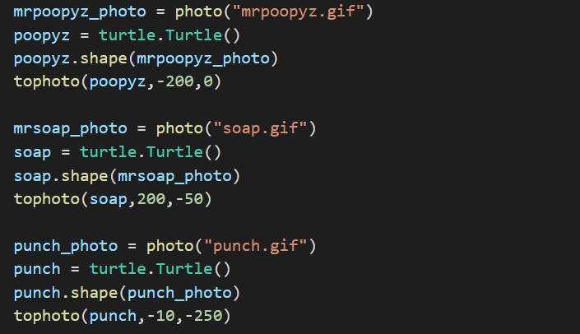

Not to brag or anything else, but i don’t use any template to know right coordinates, I actually do my own math and do some kind of trial and error a lot to find the best position for every image.

The photo function above is to register/load the image. The reason i’m using .gif is because turtle only allows gif to be the image. So, all of them is actually just a frame of photo/drawings. And the .shape is to show the image that is already been loaded to the turtle.

The tophoto function is just to move the image to the certain coordinates on the screen. The reason i use penup() is because it makes no line when direct the image to the locations.

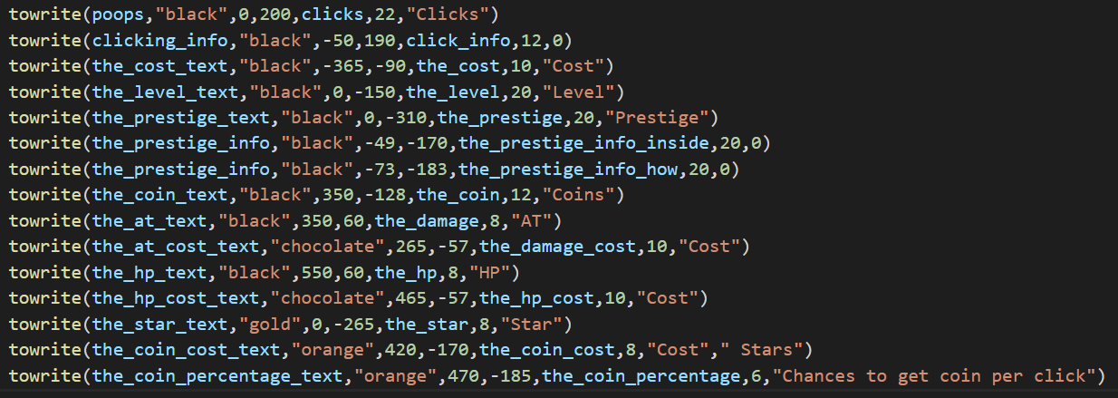

towrite function is a function that i made to write specific text and send it to the right location. There are 3 possible outcome of this function, i differentiate all of the outcomes by using if statement.

The code above is to load the background music, setting the volume and playing it in a loop ((-1)).

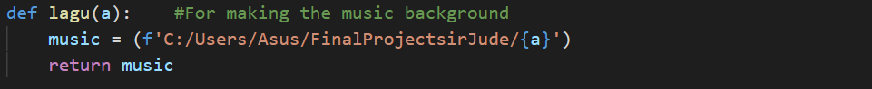

lagu function is just a simple redirect function to the folder location.



There are also a lot of sound effects that i used in the game. For this example i am showing you the punching effect of the battles. It is really simple. The effect function is just basically register the sound effects and return the registered sound just like lagu function, however in effect we are using mixer.sound .

* **The mechanics of the clicking**

This is the thing that i like with making my own game, which is i can make a different mechanic from the usual idle clicking game. In the usual idle game, the user gains the “clicking points” with the increment of the upgrades . While in my program it is different, let me show you what I’m talking about. Text
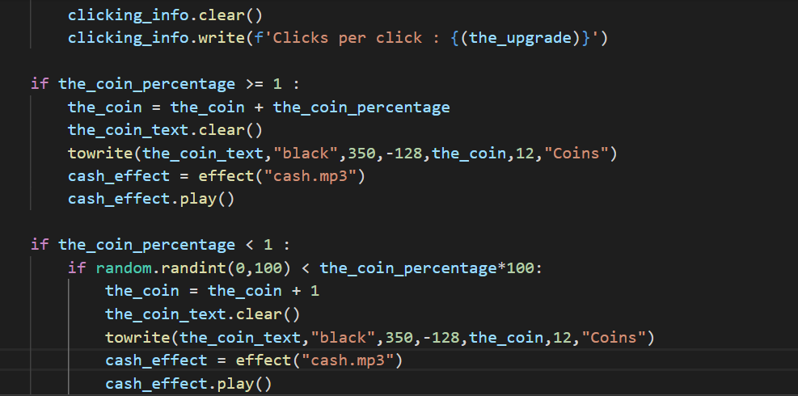

Because i wrote the saved data in other file, i need to call it first by using global. The reason i separate the progress is simple, it is because i want people who play the games do not need to fear to close the program, because it will be automatically been saved without pushing any button. And for that i write it by using the parameter function. Before i explain about parameter function let me explain to you first about the mechanic of the clicking of this game.

So the_upgrade is the gain everytime user click in the certain area(clicking the poopyz character) . For now lets focus on the first if statement first. This is why poopyz is unique. It is because in the usual game the clicking points only depends on the upgrade levels right. But, with this player is actually need to do some math to maximize the gain of clicking points. So, basically if the users want to gain more clicking progression they need to reach certain clicking points. It is kinda confusing, so let me explain you once again with examples. So when the clicking points of the users reach 50, the gain per clicking will increasing as much as the upgrade levels math. So you, cant just do auto upgrade by playing this game. You actually need to count first. So, no no to the clicking bots. Even tho, I actually managed to make the bots by myself. But, i think people can’t make a simple clicking bot just using jitbit macro clicker things.

I also add the writing code everytime user clicks the poopyz, the reason is so user will always can see the progressiong that they have made.

This is the upgrade mechanics, it is also built different. As you can see the upgrade is not immediately upgrading the clicking per clicks gain, but it upgrades the_dream. Which is the amount of the per click gains when clicking points reach certain points.

And same as the clicking function it write and send the progress to the data base in real time so the user do not need to think about saving their progress.

I also add max upgrade where the user can do one clicks to upgrade it. I actually use a loop wheren it can upgrade as many as the user can afford. So for example, if the user have 10 points, and the cost for every upgrades is for example, 1 point per upgrade. So the user can upgrade it 10 time with just 1 click in the max button upgrade.

* **The prestige**

In this part my code/prestige mechanics is actually really usual and really basic. It just resetting all of the progress with the change to gain stars and the upgrade evel gains.

As you can see from the code, it reset all of the progression, in the screenshot I make the_level goes back to level 111. It is because i am testing the prestige button a lot. In normal occasion it will goes back to level 1.

Because i don’t want Sir Jude to be angry at me, i add popups everytime you do upgrade where it will output sound effects and pause the background music until you close the popups by clicking it one time.

From above, to below

* **Coin,AT,and HP**

For the coin, i made it as a “Gacha” why i say it as gacha, it is because you can’t get coin everytime you click the poopyz. And to increase the percentage to gain the coin you need to upgrade the coin, to upgrade the coin gains percentage, you need to use your star that you already gain from the prestige. And recall to the first clicking function. There are 3 if statement right, so lets talk about the second and the third statement.

So if the user coin percentage gain is below 1, for example the user has 0.5 percentage of the gain. It is not mean that the user will get 0.5 coins per click. But actually, there will be gacha where i used random.randint, so if the user is lucky enough the actually can get a coin when the user clicks. However if they already have the percentage higher then 1. They will gain many coins based of the amount of the upgrades percentage.

Now after you gain a lot of coins, you can upgrade the attack of your character with using the coins. If you coins is greater or equals to the damage cost you will gain increament to your attack, the hitpoint mechanic is also the same. Just different sound and variable.

* **The Battle**

Before we drive into the battle. Let me show the function that i made to call this screen.

As you can see I just simply clear the first screen(the main screen) and call the function playing2() which is the battle screen.

After you open second screen you will see this interface.

As you can see there are two buttons go back and to punch, for go back button the function is the same as the first ganti function. However, for this one, the function will clear the screen 2 instead screen 1 and call back the first screen.

This screen have the minimalistic concept(obviously not because I am too lazy to add other things in this screen) jokes aside, i actually thing it is better to just make one button to battle, so it is just a simple idle cliking, i actually think to add some skills, however it looks like pokemon game, and I think it will ruin the idle pride.

There are three if statements which checking if either the player is losing or winning, or still fighting. The reason i made 3 if statement is because obviously to write the progress. If the user is losing or didn’t kill the enemy yet and they somehow exit the game, the program won’t write the progress and reset the hp of the enemy to 100%.

While if the user success to kill the enemy, they will get one gacha coin, and the enemy will level up which will upgrade the at and hp of the enemy, so it will be harder and harder every time you kill the boss. I also add two popups when you successfully kill the enemy / noobly been defeated by the enemy.

**When you die When you win**

* **One gacha pull and ten gacha pull**

After you kill the enemy, just as i said you will get one gacha coin. With that, you can use it in this window.

It is so basic, it only check if you got the legendary creepooper skin or just a normal illuminashiet skin. So every time you spend your gacha coin, your skin level will increase, your speed_level and chop level also will be increasing.

🡪

Actually the interesting part in this screen that i really proud of is the ten pulls gacha.

Why i say it is interesting you may ask? Because i’m not using loop, why again? It is because if we are using loop, you will popups all of the popups at the same time, and it is really bad. Why again? Firstly you can’t see every pull, only the last pull. Second reason is, you will only hear the sound effect once and it is not good right. You need to feel every time you gacha. So, for this reasons i made a special function which can be used to call it 10 times and remove it just by clicking it.

Basically, I made a function that can be clicked first, and I made new variable which is xaaa which will be increased by 1 everytime you click the popups. So it will doing it over-and over again until you close the 10th popups. And every time you close the popups. It will increase your skin level. The negative of this things is only if the user close the game while tha gacha pull is at the 5th time they will lose all of other skin right. Yea that’s right im so sorry. I will fix the code.(actually I just realise the flow sir)

* **Welcome to the platformer**

It is not just a platformer game, it is idle platformer games. I actually is inspired by idleon for this idea. In this screen you can walk by using the left right key, or w,a,d key and space key. Lets talk about the world making first.

* + **The World**

The function of this loop is to add the transformerd image and , the rectangle of the image. The rectangle function is for the collider of the game, but we will talk about it later. And with this loop it also state the location of fall of the rectangles/transformed image. Tile==1 is just to differentiate the block with the others. And if you see the “tile = (img,img_rect,2)) this is the one that make it happen, it will ad the tuple to the list, and with that list it will draw all of the blocks. And right after the img_rect, there is “2” right. The “2” is for telling the program if that block is a block, “1” is a platform, while “0” is a furniture. I differenciate it just to make it easier to do the collider part.

This the map I made for the platformer screen. As you can see there are different number, that’s mean I use 7 different blocks to make this world.

* + **How the character move?**

If you ask this I can simply just say, to move the character i just play with the coordinates of the character. Well, actually it is not that simple. However, I can say for the left and right it is really understandable, while for the jump part, you really need to pay attention okay.

So, to move it to the left you can either click the left key or the a key, for moving it to the right you can click right key or the d key. At glance, looking at this you probably think that dx is the x coordinate of the character. Well, you are wrong. The reason i don’t change the coordinates immediately is because it will run through the block. After this, i will explain about that. But, for now lets see the True, False. By the way, if you remember about the speed_level. You can get it by do gacha. Okay so lets talk about the if elif else statement above. So, if you click left key it will make the poop.left True and for the right key it will make the poop.right True, the reason is to make the program understand and not be confused by the code. And for the else statement, it is so it will make sure once more. Lets see the if elif statemen one more time. I also add the and. It is just a math to make sure the character not walking through the screen(screen collider).

There are two if statements for the jump movement. The first if just to check if we press the space key or no. And when we press the jump key it will – the velocity. So, again why velocity not the coordinates and why minus instead of plus. So, in pygame if we minus the coordinates it will go up, while if we plus it it will go down. And why we change the velocity, it is because we need it to go down. We will talk about the gravity after this. Lets talk about the second if statement first. The reason I make that is to make the user can’t jump by holding the space button, which mean the user need to click space key one time at a time to jump.

This is just the gravity.

* + **Collider**

I talk about it a lot before, now lets really jump into it. What is collider? It is the special barrier that is used to make sure character is not enabled to move through the blocks.

This is the collider for all of the blocks, which as i said before, if the blocks second index in the tuple is a “2” it makes the program read it as a block. For the block collider it is not that special. It just make sure if the character collide with a block it either stopping the increament of the y coordinates or the x coordinates. That way, the character can’t run through the blocks or jump through the block, and will stay on top of the block. My greatest prouds is actually about the platform. So, i made a code where the character can jump through and will stay on top of the platform.

At glance, it looked simpler then the block collider, but, I experiment with trial and erorr for hours to get this formula. Actually i just remove the go right and go left collider, and remove the can jump through if statement. But, if I don’t change the stay on top collider. It will mess up, it is really really hard to explain it, but I will try to explain, basically. If you don’t code like my code you will feel some kind of bug, where you will stay on top of the platform while just collide with the bottom side of the platform. So yeah, it is really hard to understand, and this is the biggest challenge for me.

* + **The run animation.**

First of all i load the picture first for when the character running to right and make it all into a variable, and for the character running to the left, i use flip. To transform it from seeing right to seeing left.

With this function it will read either i press the left or right key. And with that information it will read over the list with the animation image. And it will give the animation when the character is running.

* + **Idle chopping wood**

By the way self.rect is to make the collider for the character.

Anyway, first i made the hitbox of the tree first.

And then i make the hitbox but with get_rect(). And then, i blit the tree to the screen, with the same coordinates with the hitbox.

And then, i use this function so every time i click the tree and i stand close enough to the tree, i will make the chop to True. And with that information.

So,every time the poop.chop get True it will longer the poop.length, which will give the loading animation when you chopping the tree. After you wait until the bar is full, you will get poop.chop = False and increament of the woods and make the loading bar to 0 again. And after that, you will be enabled to click the tree again, and do it all over again.

I think that’s just it for our journey Sir Jude, i hope you really read my report, and i am sorry if there are some mistakes that i made, or some words that is hurting your feeling. Anyway, really thank you for the attention and for the time to read my reports. Much love.

**REFERENCES**

[pygame.Rect — pygame v2.1.1 documentation](https://www.pygame.org/docs/ref/rect.html)

stackoverflow.com

geeksforgeeks.com

Reference on making platformer game, and to learn about pygame.

[Coding With Russ - YouTube](https://www.youtube.com/channel/UCPrRY0S-VzekrJK7I7F4-Mg)